CS 318 – Architecture and Organization
LEARNING TASK (STRUCTURED ASSEMBLY LANGUAGE P1)

NAME: JOSHUA JERICHO D. BARJA SECTION: BSCS-3A

SAMPLE RUN
Step-by-step sample run of your assembly program with explanation.
Step 1  - Create file that has an .asm extension (e.g, sample.asm)  - In your dedicated terminal, run the command <nasm -f win32 sample.asm -o sample.o> then hit enter.  - After the first bash/command, type in another bash/command <gcc sample.o -o sample.exe> to perform linking then press enter to execute. | Image 1  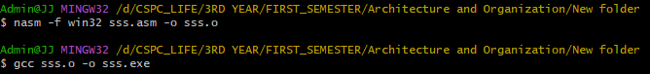
Step 2  - Run the executable file using the command <./yourExeFile.exe> in your dedicated terminal and hit enter to execute. | 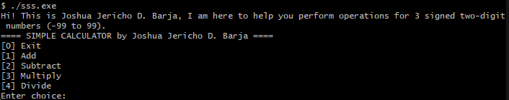
Step 3  - Enter a number ranging from 1-4. Choose what operation you want to try: | 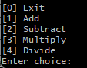
  ± | 1 | 2 | 3 | 4
  add | ×
  sub |  | ×
  mul |  |  | ×
  div |  |  |  | ×

TEST CASES | RESULTS
Addition inputs (2, 3, -4)  Expected result: 1 | 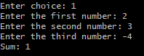
Subtraction inputs (3, -2, -5)  Expected result: 10 | 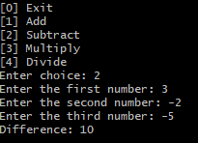
Multiplication inputs (2, 2, 2) and (2, -2, -1)  Expected result: 8 and 4 | 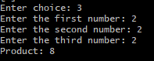  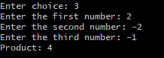
Division inputs (2, 19, 9)  Expected result:  Enter the first number: 2  Enter the second number: 19  Quotient: 0  Remainder: 2  Enter the third number: 9  Quotient: 0 | 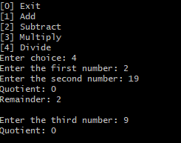
ERRORS | RESULTS
Expected numbers ranging from -99 to 99 | 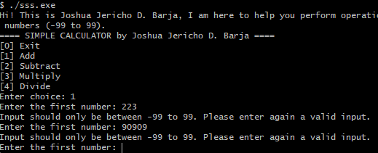
Division Error | 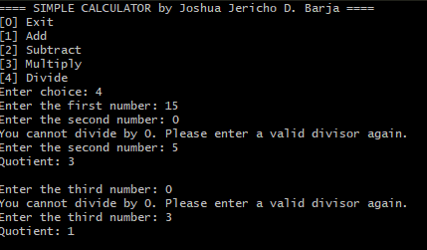

ASSEMBLERS INSTRUCTIONS
Selection Statements | Iterative Statements
cmp – Compares two values to determine the next action. It is used to check the user’s menu choice to decide which arithmetic operation to execute and to validate input values within the allowed range (-99 to 99).  je (jump if equal) – Transfers control to a specific section if the compared values are equal. For example, it jumps to the addition, subtraction, multiplication, or division routines based on the user’s choice.  jne (jump if not equal) – Transfers control when the compared values are not equal. It is used to ensure the divisor is not zero before performing division.  jl / jg (jump if less / jump if greater) – Used to enforce input constraints. If a number is less than -99 or greater than 99, the program jumps to a routine that prompts for a valid input. | jmp – Used to repeat a section of code until a condition is met. Examples:  menu_loop – Loops the main menu until the user chooses to exit.  get_input_loop – Repeats the input prompt until a valid number is entered.  divisor_check – Repeats the second number input if the divisor is zero.  thirdnum_check – Repeats the third number input if it is zero.  Labeled loops (menu_loop, get_input_loop, divisor_check, thirdnum_check) – Ensure repeated execution of prompts and validation, preventing invalid inputs or division by zero, while maintaining smooth program flow.

PROGRAM CODE
section .data
header_msg db 'Hi! This is Joshua Jericho D. Barja, I am here to help you perform operations for 3 signed two-digit numbers (-99 to 99).', 10, \
'==== SIMPLE CALCULATOR by Joshua Jericho D. Barja ====', 10, 0
options db '[0] Exit', 10, \
'[1] Add', 10, \
'[2] Subtract', 10, \
'[3] Multiply', 10, \
'[4] Divide', 10, 0
choice db 'Enter choice: ', 0
firstNum db 'Enter the first number: ', 0
secondNum db 'Enter the second number: ', 0
thirdNum db 'Enter the third number: ', 0
input_format db '%d', 0
exit_msg db 'Thank you!', 10, 0
not_valid db 'Input should only be between -99 to 99. Please enter again a valid input.', 10, 0
zero_divisor db 'You cannot divide by 0. Please enter a valid divisor again.', 10, 0
sum_msg db 'Sum: %d', 10, 0
sub_msg db 'Difference: %d', 10, 0
mul_msg db 'Product: %d', 10, 0
div_msg db 'Quotient: %d', 10, 0
div_remainder db 'Remainder: %d', 10, 0
new_line db 10, 0

section .bss
choice_num resd 1
fNum resd 1
sNum resd 1
tNum resd 1
result resd 1
remainder resd 1

section .text
global _main
extern _printf
extern _scanf

_main:

menu_loop:
; print header message
push header_msg
call _printf
add esp, 4

; print options
push options
call _printf
add esp, 4

; ask for choice
push choice
call _printf
add esp, 4

; read choice
push choice_num
push input_format
call _scanf
add esp, 8

; load option into eax register
mov eax, [choice_num]

; exit program if 0
cmp eax, 0
je exit_loop

; addition
cmp eax, 1
je addition

; subtraction
cmp eax, 2
je subtraction

; multiplication
cmp eax, 3
je multiplication

; division
cmp eax, 4
je division

; invalid choice, loop again
jmp menu_loop

;---------------------------------------------- ADDITION ----------------------------------------------
addition:
; first number
push fNum
push firstNum
call get_valid_input
add esp, 8

; second number
push sNum
push secondNum
call get_valid_input
add esp, 8

; third number
push tNum
push thirdNum
call get_valid_input
add esp, 8

; compute result
mov eax, [fNum]
add eax, [sNum]
add eax, [tNum]
mov [result], eax

; print the result
push dword [result]
push sum_msg
call _printf
add esp, 8

; newline for spacing
push new_line
call _printf
add esp, 4

; jump back to menu
jmp menu_loop

;---------------------------------------------- SUBTRACTION ----------------------------------------------
subtraction:
; first number
push fNum
push firstNum
call get_valid_input
add esp, 8

; second number
push sNum
push secondNum
call get_valid_input
add esp, 8

; third number
push tNum
push thirdNum
call get_valid_input
add esp, 8

; compute result
mov eax, [fNum]
sub eax, [sNum]
sub eax, [tNum]
mov [result], eax

; print the result
push dword [result]
push sub_msg
call _printf
add esp, 8

; newline for spacing
push new_line
call _printf
add esp, 4

; jump back to menu
jmp menu_loop

;---------------------------------------------- MULTIPLICATION ----------------------------------------------
multiplication:
; first number
push fNum
push firstNum
call get_valid_input
add esp, 8

; second number
push sNum
push secondNum
call get_valid_input
add esp, 8

; third number
push tNum
push thirdNum
call get_valid_input
add esp, 8

; multiply
mov eax, [fNum]
imul eax, [sNum]
imul eax, [tNum]
mov [result], eax

; print the result
push dword [result]
push mul_msg
call _printf
add esp, 8

; newline for spacing
push new_line
call _printf
add esp, 4

jmp menu_loop

;---------------------------------------------- DIVISION ----------------------------------------------
division:
; first number
push fNum
push firstNum
call get_valid_input
add esp, 8

divisor_check:
; second number (divisor)
push sNum
push secondNum
call get_valid_input
add esp, 8

; check if second number is zero
mov eax, [sNum]
cmp eax, 0
jne perf_division1 ; if not zero, proceed
push zero_divisor
call _printf
add esp, 4
jmp divisor_check ; repeat only the second number

perf_division1:
; divide first number by second number
mov eax, [fNum]
cdq
mov ebx, [sNum]
idiv ebx
mov [result], eax
mov [remainder], edx

; print quotient
push dword [result]
push div_msg
call _printf
add esp, 8

; print remainder if non-zero
cmp dword [remainder], 0
je skip1
push dword [remainder]
push div_remainder
call _printf
add esp, 8
skip1:
push new_line
call _printf
add esp, 4

thirdnum_check:
; third number
push tNum
push thirdNum
call get_valid_input
add esp, 8

; check if third number is zero
mov eax, [tNum]
cmp eax, 0
jne perf_division2 ; if not zero, proceed
push zero_divisor
call _printf
add esp, 4
jmp thirdnum_check ; repeat only the third number

perf_division2:
; divide previous result by third number
mov eax, [result]
cdq
mov ebx, [tNum]
idiv ebx
mov [result], eax
mov [remainder], edx

; print final quotient
push dword [result]
push div_msg
call _printf
add esp, 8

; print remainder if non-zero
cmp dword [remainder], 0
je skip2
push dword [remainder]
push div_remainder
call _printf
add esp, 8
skip2:
push new_line
call _printf
add esp, 4

jmp menu_loop

; ---------------------------------------------- VALIDATION FUNCTION ----------------------------------------------
get_valid_input:
push ebp
mov ebp, esp

get_input_loop:
; display prompt
push dword [ebp + 8] ; prompt message
call _printf
add esp, 4

; read number
push dword [ebp + 12] ; variable address
push input_format
call _scanf
add esp, 8

; load number to eax
mov ebx, [ebp + 12]
mov eax, [ebx]

; check range -99 to 99
cmp eax, -99
jl invalid_input
cmp eax, 99
jg invalid_input
jmp valid_input

invalid_input:
push not_valid
call _printf
add esp, 4
jmp get_input_loop

valid_input:
pop ebp
ret

;---------------------------------------------- EXIT PROGRAM CODE :> ----------------------------------------------
exit_loop:
push exit_msg
call _printf
add esp, 4
ret

